**CSE541 Computer Vision**

**Prof. Mehul Raval**

**Gaze Tracking**

**Week 3 Report**

| **Name** | **Enrolment Number** |
| --- | --- |
| Nityam Dixit | AU2040140 |
| Devyash Shah | AU2040152 |
| Kavan Gondalia | AU2040030 |
| Kush Patel | AU2040137 |

# Tasks Performed in the week

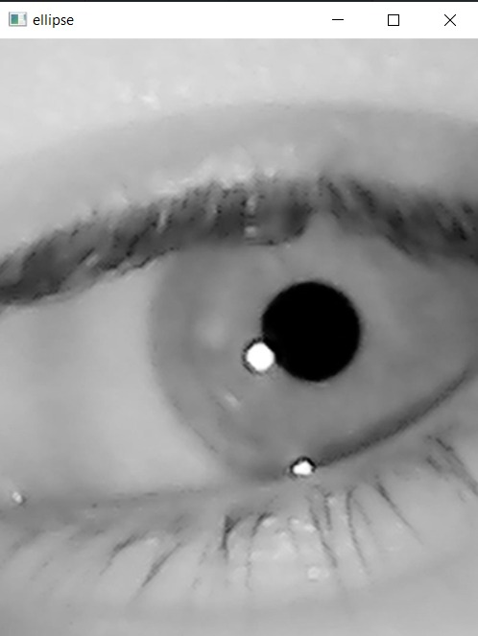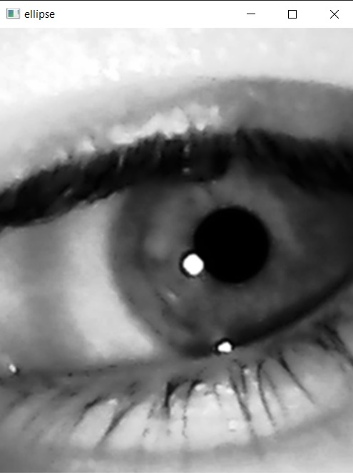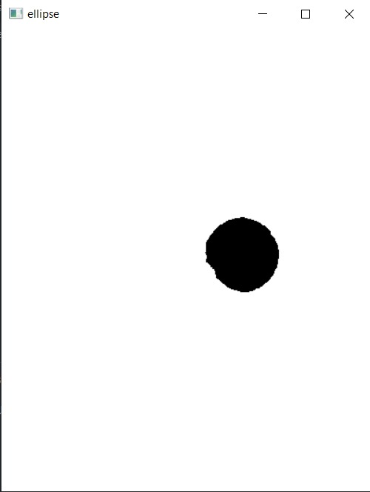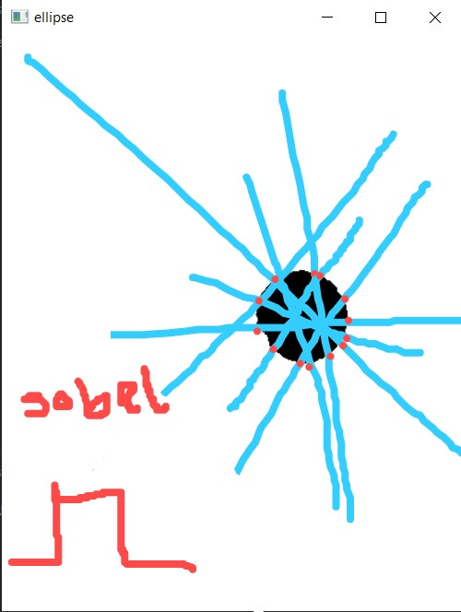

Generating random lines and using the Sobel operator on each line to find the contour points.

After having the contour points, we fit an ellipse with the cv2.fitellipes() method.

# Outcomes of the tasks performed

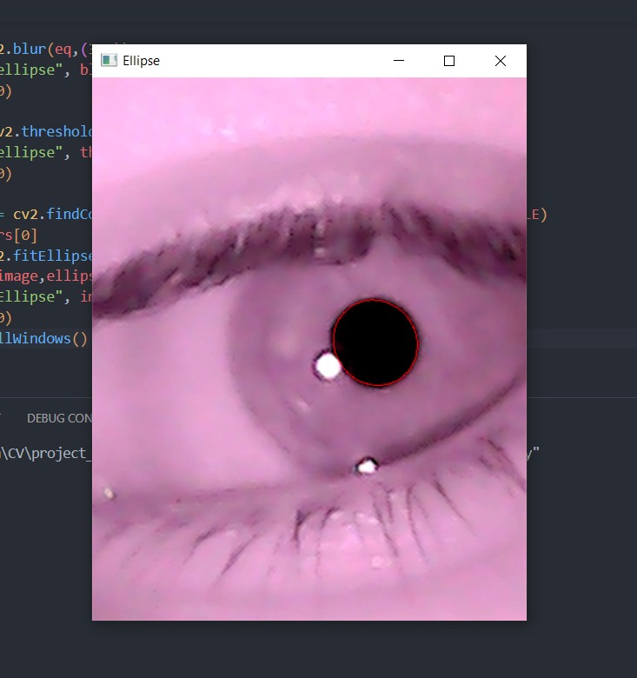

We were able to generate a perfect fitting boundary to the image

# Tasks to be performed in the upcoming week

Our camera has a meagre frame rate of 10 fps.

Trying to get each frame’s fitting on the video. We have a hardware requirement of IR Led and plan to mount the whole camera set up to a wearable stand.